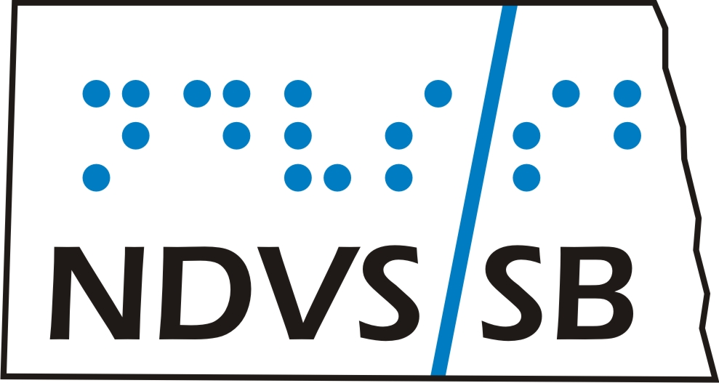

STUDENT/PARENT HANDBOOK

2019 - 2020



Division of North Dakota Department of Public Instruction
Kirsten Baesler, State Superintendent
600 E. Boulevard Ave., Dept 201
Bismarck, ND 58505-0440
www.dpi.state.nd.us

Our Mission

NDVS/SB provides individualized services and resources to infants, children and adults with visual impairment to empower them in achieving their goals.

TABLE OF CONTENTS

General Info/Facility/Program Participation 4

Attendance 5

Confidentiality 5

Educational Program 8

DPI High School Credit 8

Dining/Food 8

Medical Services 9

Viewing and Using Entertainment 10

Telephone Usage 10

Internet/Email/Social Networking Policy 10

Dress Code 11

Visitors 11

Inclement Weather/School Closing 12

Mandatory Reporting 12

Prohibited Items 12

Student Conduct 13

Behavior Consequences 14

Handbook Agreement 15

General Information
Welcome! We want your participation in our Short-Term Program with us to be positive, productive and beneficial. Breakfast, lunch and dinner are provided as well as bedding and towels. You are asked to bring your own personal items such as clothing and toiletries to last the duration of your stay. Please bring a small amount of spending money if possible.

We expect students to use good judgment, adhere to our guidelines and display common courtesies. Students are expected to continue to carry out the rules from their local school handbook while attending programming at our agency.

Facility/Program Participation:

- Respect the “Lights-Out” scheduled time.
- Short-term Programming grades 1-6 – 8:30 pm
- Short-term Programming grades 7-12 – 9:30-10:00 pm

- Respect other people’s privacy, belongings, and personal space.

- NDVS/SB is not responsible for lost or stolen articles.
- We encourage labeling all personal items including clothing.
- Students are responsible for the care and appropriate use of all personal belongings including electronic devices.

- Students are expected to keep their sleeping quarters neat.

- Students and visitors are not allowed in bedroom areas of the opposite gender, other than parents.

- The gym is available for use after school hours; students must be supervised by a staff member.

- Weapons of any type are not allowed on campus. Any item perceived as a weapon will be kept in the office until Friday upon the conclusion of the program.

Attendance:

- Students are required to follow their schedule to the best of their ability. Revisions can be made by talking with appropriate staff.

Confidentiality:

We adhere to the Family Educational Rights and Privacy Act (FERPA), a Federal law that protects the privacy of student education records. NDVS/SB Confidentiality Policy guarantees:

- The complete privacy of school records of every enrolled student or formerly enrolled student from unwarranted inspection by or communication to any unauthorized individual or agency.

- All parents, even those not having custody of their children, have access to each record kept on a child, unless barred by the court.

- NDVS/SB will not release records to any other party or agency without the prior written consent of the parent, guardian, or eligible student. Consent from either parent is sufficient, unless a court order specifies both parents must sign.

- NDVS/SB may disclose information to officials of the local school district collecting or using the information. Information will not be released to participating agencies without parental consent except as follows:

  - NDVS/SB may disclose personally identifiable information from the educational records of a student without the written consent of the parent or eligible student if the disclosure is to other school officials, including teachers, within the educational institution or local educational agency who have been determined by the agency or institution to have legitimate educational interests or to the officials of another school or school system in which the student seeks or intends to enroll; subject to the requirements set forth in "b." of this section.

  - NDVS/SB shall make reasonable attempt to notify the parent or eligible student except when disclosure is initiated by the parent or eligible student. It is the NDVS/SB policy to forward educational records upon request to a school in which a student seeks enrollment.

NDVS/SB upon receiving personally identifiable information from another educational agency or institution may make further disclosure of the information on behalf of the agency without prior written consent if the conditions in "a." and "b." of this section are met and if NDVS/SB informs the party to whom disclosure is made of these requirements.

If a parent refuses consent for the release of information to a third party, the party may proceed with the due process hearing procedures.

  - NDVS/SB may legally submit any designated portion of a student's record when authorized by judicial subpoena issued by the probate or other duly constituted court without consent, but with prior notification given to parents, legal guardians and eligible students of the data transmitted.

- When disclosure of records is made to a third party, it is on the condition that the records not be further disclosed without written parental consent.

- It is the responsibility of the Superintendent to ensure the confidentiality of records at NDVS/SB and to provide appropriate training or instruction to persons collecting or maintaining personally identifiable data.

Confidentiality is the shared responsibility of every staff member who works with the students at NDVS/SB. Every student's right to privacy must be protected at all times.

- PARENT/STUDENT ACCESS - Parents, legal guardians or eligible students have the right to inspect and review any educational records which are collected and maintained by NDVS/SB. The school shall comply with a written request without unnecessary delay and within forty-five (45) calendar days after a request is received. Parents, legal guardians or eligible students requesting records for use at an Individualized Educational Planning Committee meeting, a hearing or a hearing appeal shall be given immediate access to the requested records.

- ACCESS RESTRICTIONS - Parents, legal guardians and eligible students may at no time inspect the records of other students. If an educational record contains information on more than one child, the parents of those children may inspect only the information relating to their child or be informed of that specific information.

- Professional workers undertaking educational research may be provided access to educational records without written consent when personally identifiable information has been deleted.

Educational Program:

- NDVS/SB offers programs and services designed to serve individuals of all ages with visual impairments or blindness. Some of the programs are located at Center Base in Grand Forks, North Dakota, and others are provided through our Outreach Offices throughout the state.

- The Center Base programs are offered during designated weeks throughout the year and are structured to provide short term programming, typically one-week sessions. The focus is teaching the Expanded Core Curriculum, as well as providing support in the course work that takes place in the local schools.

- The Expanded Core Curriculum includes the following areas:

- Compensatory Access, e.g. alternate communication modes, braille, enlarged or enhanced print and/or recorded materials
- Sensory Efficiency - use of low vision devices, etc.
- Orientation and Mobility
- Social Interaction Skills
- Independent Living Skills
- Recreation and Leisure Skills
- Career Education and Exploration
- Use of Assistive Technology
- Self Determination

- NDVS/SB supports the Local Education Agency by participating in IEPs for students who qualify for services, per request. Case Management is maintained at the local school. The Expanded Core Curriculum areas, those areas of instruction that are unique to this population of students, are to be included as deemed necessary and appropriate in regards to the National Agenda, and the needs of the student.

ND Department of Public Instruction – High School Credit

- We offer high school credit for students who partake in our Short-Term Programs in collaboration with their Local Education Agency.

- Course Code 19246
Visual Impairment Expanded Core Curriculum
Expanded Core Curriculum Skills course addresses the unique, specialized needs of learners with a visual impairment. This course is designed to teach techniques and give concentrated instruction to promote independence in the following areas: Communication Modes, Braille Music, Orientation & Mobility, Social Interaction Skills, Independent Living Skills, Career Education, Use of Assistive Technology, Visual Efficiency Skills, Recreation and Leisure Skills, and Self Determination Skills.

- ND Century School Code: 15.1-21-03
A unit of high school credit must consist of at least one hundred and twenty hours of instructional time per school calendar. The Expanded Core Curriculum is approved for credit, as an elective when taught by a highly qualified teacher (TVI). The credit can be offered in increments of ¼, ½, or 1.

Dining/Food:

- Healthy food and beverages will be offered and encouraged during meals and scheduled breaks. Pop and candy are not allowed during class, meal times or after 9:00 p.m. Instructors will have discretion for special events.

- Any food allergies should be reported on the Student Data form prior to attending our Short-Term Program.

Medical Services:

- All prescription and over-the-counter (OTC) medication must be sent in its original container and will be kept in a locked cabinet while attending our Short-Term Program.

- Any medical concerns that come up during the week will be addressed with the parents and appropriate action taken.

- A nurse is available to dispense morning and evening medications. OTC medications may be dispensed to the student with parental permission.

- Meeting the needs of students with chronic medical conditions will be discussed prior to attendance to determine the ability of NDVS/SB to appropriately provide support.

- If a child becomes too ill to attend classes, the student program coordinator will notify the parents. If a student has a fever, is vomiting, experiencing diarrhea or other symptoms, arrangements will be made for the student to go home. The consulting nurse may also be involved with the decision based on the discretion of the student program coordinator.

- Students needing the services of a physician will be taken to a local doctor’s office or the hospital for emergencies.

- Communicable Diseases and Universal Precautions will be followed according to the “Health Guidelines for North Dakota Schools.”

- Financial responsibility for medical services obtained in the community, medications, doctor appointments, hospital, etc. are the responsibility of the parents.

- It is the parent’s responsibility to arrange for and take children to routine medical or dental appointments.

- Please report all medical allergies prior to attending our Short-Term Programs.

Viewing and Using Entertainment:

- Guidance and discretion will be used by staff and is expected of students when choosing movies, video games and/or TV programs. TV viewing is allowed at the discretion of staff.

- Please be considerate of others in regards to the volume of the television, personal media players and other devices.

Telephone Usage:

- Students may not place or receive calls during instructional times unless deemed appropriate by staff. Instructional schedules are available for parents during check-in on Sunday evenings or upon request.

- Cell phones are not to be used during instructional hours unless permission is given by an Instructor. If cell phone usage becomes an issue, the phone may be kept in the office during the school day and parents may be notified.

Internet/Email/Social Networking Policy:

NDVS/SB recognizes the value of the internet, email, and social networking (from this point forward the term internet will be all inclusive) as tools for communication and sources of information for students.

The following guidelines apply to all users:
- Students are prohibited from sending or posting electronic messages that are abusive, obscene, sexually oriented, threatening, harassing, damaging to another’s reputation, or illegal.
- Any person taking, disseminating, transferring or sharing obscene sexually oriented, lewd or otherwise illegal images or other content will be disciplined accordingly.

Remember, the use of the Internet is a privilege, not a right.

Dress Code:

Students are encouraged to develop and use their own good judgment as to clothing appropriate for the occasion and the weather.

- Appropriate clothing and shoes are required. Staff has the discretion to ask students to change clothing if deemed inappropriate.

- Weather conditions may require hats, mittens, boots, rain gear and other warm clothing for outdoor training and activities.

- Use of profanity, racial slurs, and such language in books, music or on clothing items is prohibited.

Visitors:

- Visitors are welcome with parent permission and need to check-in at the main desk. If visitors arrive after 4:30 pm, they must check-in with the supervising staff. We ask that visitors leave by “lights out.”
- Students are asked to be involved in all evening programming activities even with a visiting guest present.

- Visitors are expected to follow the same guidelines as the students attending programming.

- Students are required to be accompanied by staff when leaving the building, unless parental permission has been given to leave campus with family or friends.

Inclement Weather/School Closing:

In the event of a school closure:
- Parents/families will be contacted if the weather will affect their travel.
- When students are participating in Short-Term Programs, staff will be providing limited activities.

Mandatory Reporting:

Because of their regular contact with school age children, school employees are required to report suspected abuse or neglect of children.

- To comply with the law (NDCC 50-25.1-03), it is the policy of NDVS/SB that any teacher or other school employee who suspects that a child under 18 years of age has been neglected or physically abused (including sexual or emotional abuse) by any person, including parent or other person (other than by accidental means), shall make a written report to the Superintendent. The Superintendent shall then immediately file a report with the Department of Social Services between 8:00 a.m. and 4:30 p.m. (telephone 787-8500) or the city police after hours (telephone 787-8000 or 911).

- A person who has reasonable cause to believe that a student over the age of 18 whom is a vulnerable adult has been subjected to abuse or neglect, or who observes a vulnerable adult being subjected to conditions or circumstances that reasonably would result in abuse or neglect, may report the information to NDVS/SB or the Superintendent or to an appropriate law enforcement agency. A law enforcement agency receiving a report under this section shall immediately notify NDVS/SB or the Superintendent of the report (NDCC 50-25.2-03).

Prohibited Items:

- NDVS/SB is an alcohol, drug, and smoke free campus. Cigarettes and the use of tobacco products including e-cigs and vaping are prohibited on campus as per NDCC 23-12.

- Examples of prohibited items include but are not limited to: fireworks of any kind; box cutter, or any other object used in a way that threatens or inflicts bodily injury to another person; firearm, a “look-a-like” weapon; air-gun or BB gun; ammunition; stun gun; pocket knife; mace or pepper spray; pornographic material; matches or a lighter; or a laser pointer for other than approved use.

- Individuals who are observed having or using any of the prohibited items on NDVS/SB property are subject to discipline and confiscation of prohibited item.

- Enforcement of this policy will depend upon the cooperation of all individuals involved; staff and student alike. All individuals on school premises share the responsibility of adhering to and enforcing this policy.

Student Conduct:

All students have the responsibility to assist in maintaining a safe and harmonious environment. Willful conduct such as bullying, harassment, verbal and/or nonverbal intimidation or threats, stalking, assault, fighting, inappropriate-rough play, vulgar and indecent behavior, insubordination and any other willful conduct which materially and substantially disrupts the rights of other students to an education is prohibited. This includes bullying, harassment, and intimidation or threats through electronic (email) and Internet use. Any student committing such acts shall be subject to appropriate disciplinary action depending on severity including verbal warning, detention, and suspension. Students have the responsibility to observe the same high standard of conduct described in this section of the handbook when they participate in all school functions/activities including any organized trips off the premises.

Definitions:
- Assault: any unlawful physical attack upon another student; an attempt or threat to act violently to another student, with or without physical contact.

- Detention: Students may be taken out of a certain class period or lose privileges to attend any extracurricular activities/school functions. Parents will be notified.

- Fighting: to contend with (verbally or physically) against another student or staff in any manner.

- Insubordination: the quality or condition of being disobedient; defiance.

  - Suspension: Students will no longer be allowed to participate in that programming week. Parents/guardian will be asked to pick up the student. Participation in future STP weeks will be determined based on discussion with the school and parents

Behavioral Consequences:

Staff will utilize positive behavioral approaches to discipline. Staff will provide verbal warnings along with consequences. Students who have not responded cooperatively with verbal warnings and natural consequences may be restricted from recreational activities and parent will be notified. As mentioned above, detention or suspension will be potential consequences if the conflict cannot be resolved.

The Superintendent will be notified if there are severe or chronic violations of student conduct. Parents will be contacted to discuss consequences which may include being sent home.

* Students with formal behavioral plans as established by the IEP Team will be adhered to the best of our ability, based on resources, training and staffing.

NDVS/SB’s guidelines are to ensure all participants have a safe and educational experience while attending our Short-Term Programs.

Student Handbook Acknowledgement of Agreement

I have read The Student Handbook and will follow these guidelines.
Please sign and date this Handbook Agreement to NDVS/SB.

_______________________________ ____________
Student Signature Date

_______________________________ ____________
Parent/Guardian Signature Date

