NDVS/SB Short Term Program
10th - 12th Grade
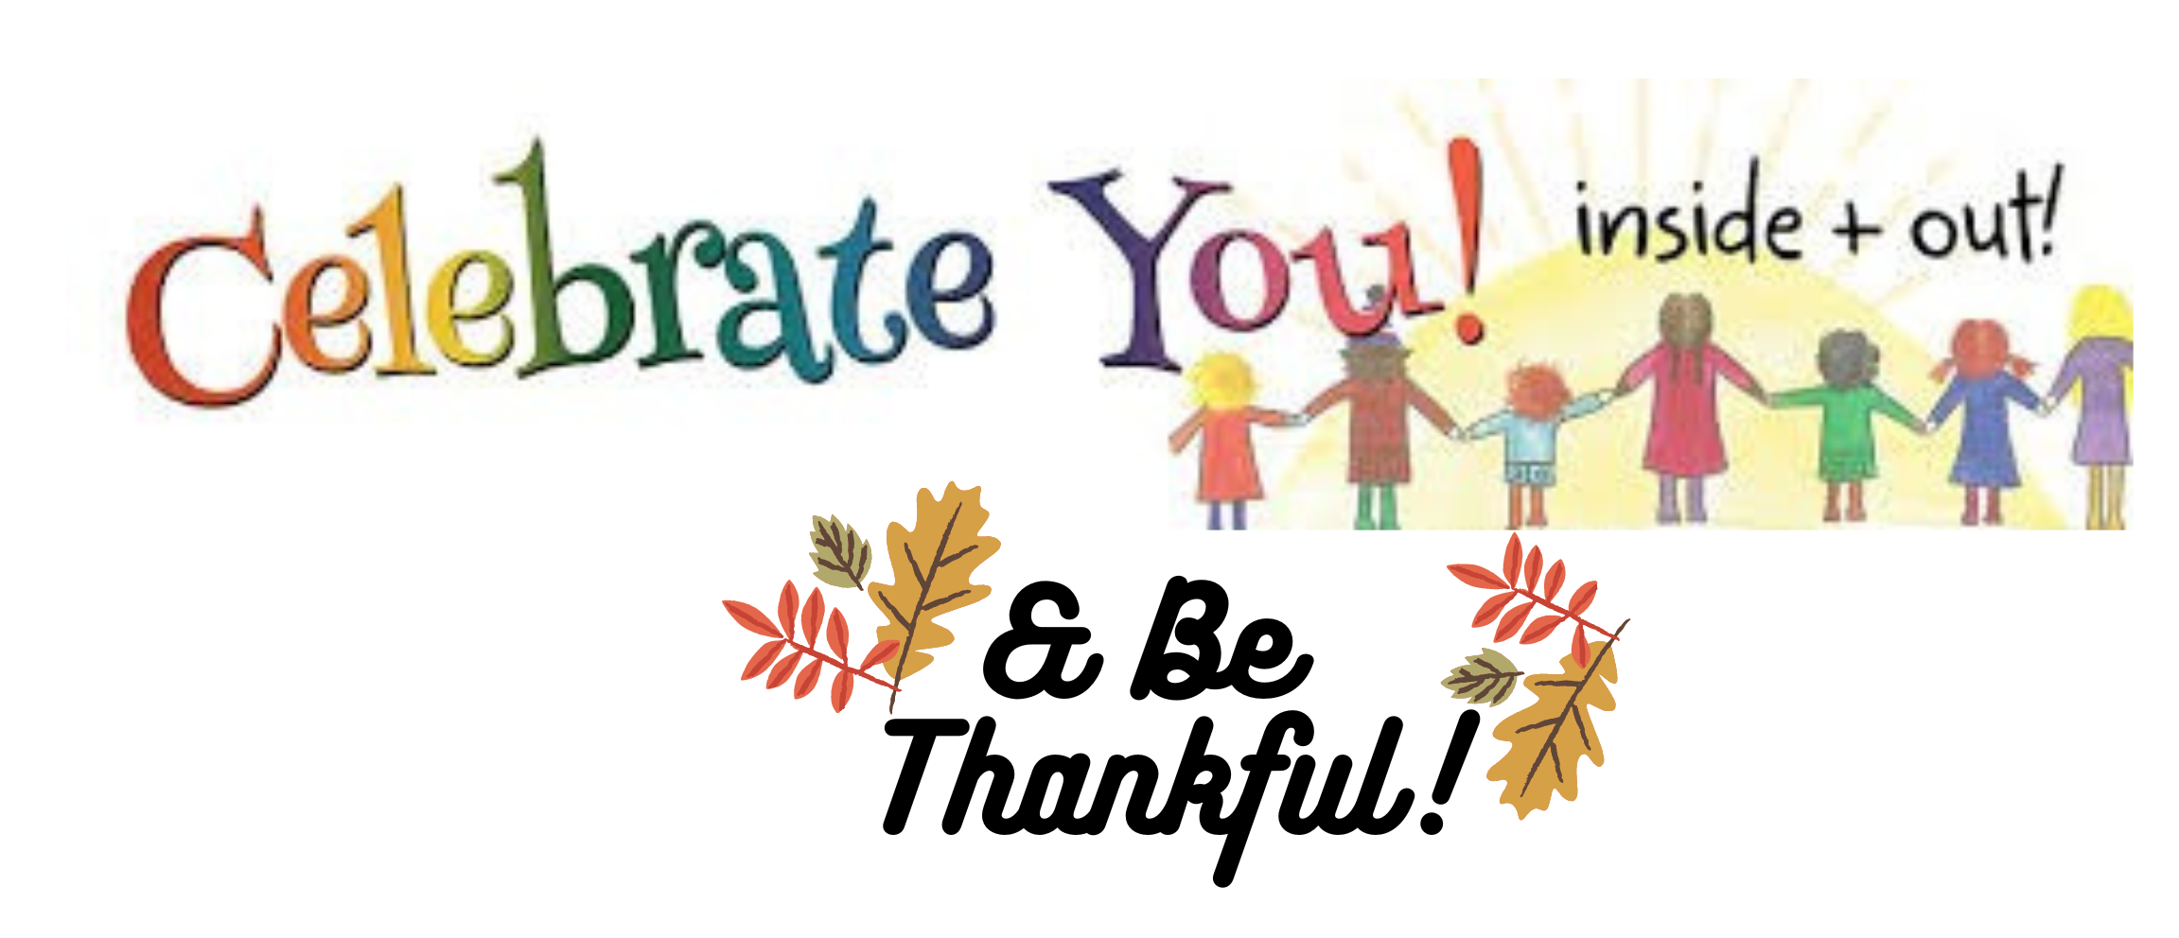

Job Shadow Experience

Vocational Tour

Career Class

Daily Living Skills

Orientation & Mobility

Technology Class

Braille Refresher Class

Social Skills
Opportunities and Classes Offered
When: Nov. 13-17, 2022

Starting Time: Nov. 13th, Sunday
Arrive between 4:30-5:30pm

Ending Time: Nov. 17th, Thursday
Pick up at 4pm

Registration Deadline: November 3rd
Register now for our educational program which is filled with instruction and experiences focusing on independence and the Expanded Core Curriculum (ECC). This includes the opportunity to take part in our Independent Living Program which includes living in an apartment setting and experiencing daily living on your own! (Guidance of skilled staff). Space is limited!

School Assignments: There will be limited time allotted to work on school assignments. We ask that only the necessary homework be sent. Instruction on the ECC will be our focus! Please bring technology devices (such as laptop, iPad, Braillenote, etc.) that you use to work on your school curriculum.

What to Bring: Business casual clothing for job sites; outdoor clothing/gear; personal items including PJ’s, robe, slippers, toiletries; modest swimwear; $10-$20 spending money; any over the counter medicines you may need such as Tylenol, and prescription medications.

Cindy Williams, Coordinator of Student Programs, ckwillia@nd.gov
Shanna Hanson, Transition/Careers Instructor, Shanhan@nd.gov

